FOR SALE: 5440 CHANNING RD. BALTIMORE COUNTY, MD 21229
$155,000 with LESS $40,000 SOFT SECOND MORTGAGE
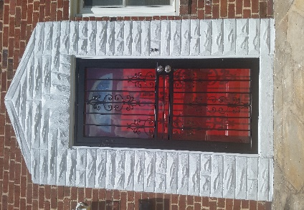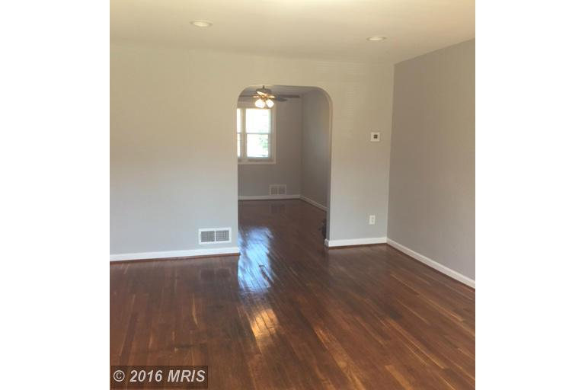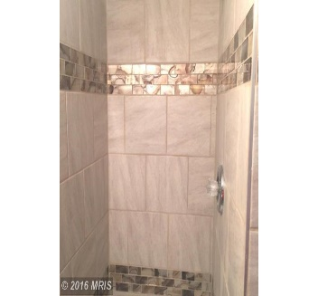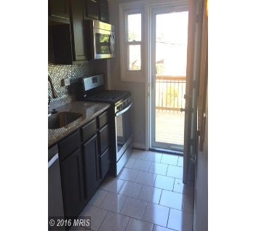

• 3 bedrooms

• 2 full baths

• New Stainless Kitchen

• New Heating & A/C

• Hardwood Floors

• Within minutes of downtown, close to BWI, route 40 & I695

• Convenient to several shopping centers, schools, parks & transit

· This home is available for sale to buyers who earn up to 80%of the median income. Homeownership education is required, contact a Baltimore County HUD-approved Housing Counseling Agency.

Household Size | 1 | 2 | 3 | 4 | 5 | 6 | 7 | 8
Income Limit | $46,000 | $52,600 | $59,150 | $65.700 | $71,000 | $76,250 | $81,500 | $86.750

Have your agent contact our listing agent Candis Carr at ExecuHome Realty (410) 654-0202 or candis_carr@yahoo.com
http://mrislistings.mris.com/DE.asp?k=3323457X5F62&p=DE-345043540-168

